## PART 1: Process Monitoring using `top`

### Scenario
An administrator needs to monitor system performance and running processes.

### Tasks

- Display all running processes using a process monitoring tool.
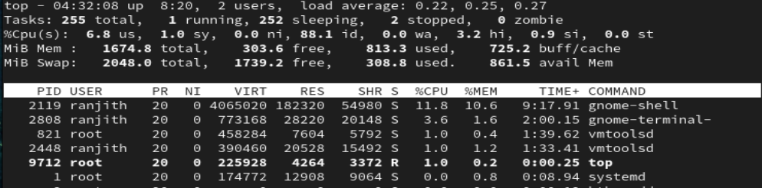
- Identify the process with the highest CPU usage.
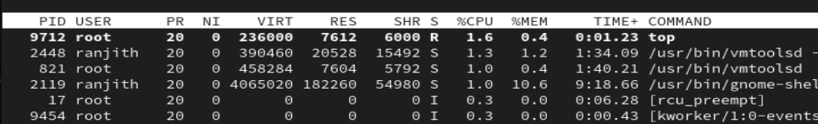
- Identify the process with the highest memory usage.
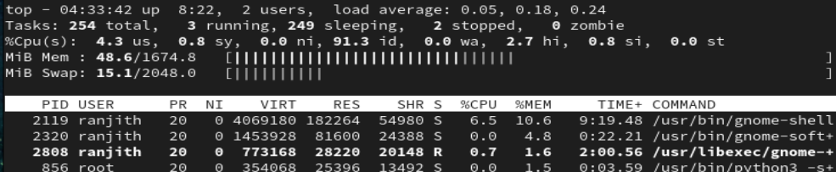
- Observe the PID, USER, CPU%, and MEM% columns.
- Sort processes based on CPU usage.
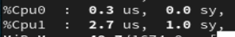
- Sort processes based on memory usage.
- Identify system load average values.
- Exit the process monitoring screen.
- Reopen the monitoring tool and verify changes.
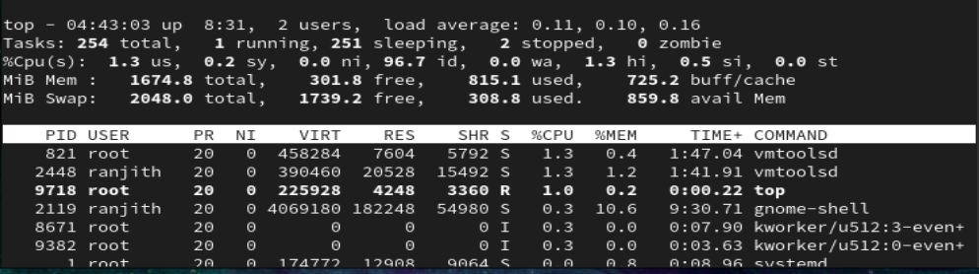
- Record observations.
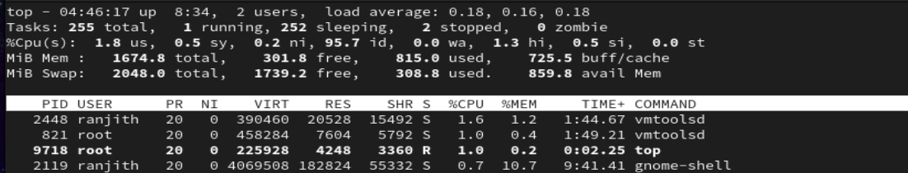

---

## PART 2: Process Priority and Nice Value

### Scenario
Some processes should run with **lower priority** so they do not affect system performance.

### Tasks

- Create a process that runs for a long time.
- Check the default nice value of the process.
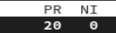
- Start a process with a custom nice value.
- Verify the nice value of the newly started process.
- Identify the difference between default and custom nice values.

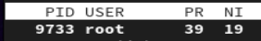
- Change the nice value of a running process.
- Verify the updated priority.
- Observe how priority affects CPU usage.
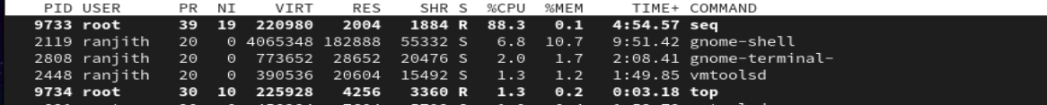
- Record observations.
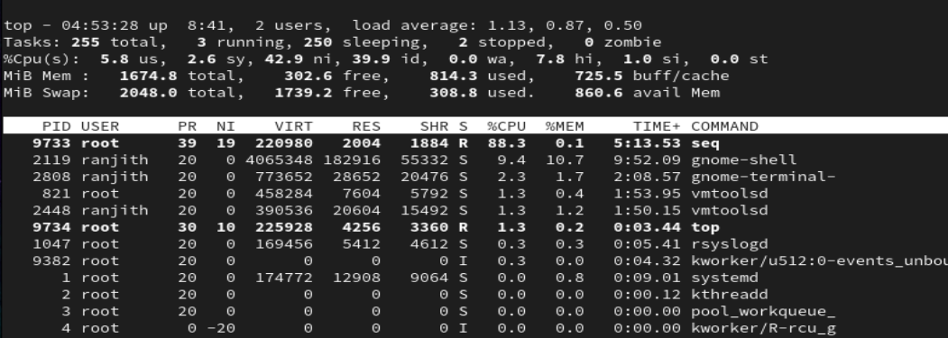
- Exit the process safely.
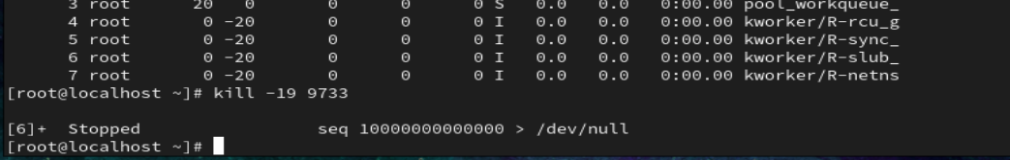

---

## PART 3: Renicing a Running Process
### Scenario
A running process is consuming excessive CPU and needs priority adjustment.
### Tasks
- Identify the PID of a running process.

- Check the current nice value of the process.
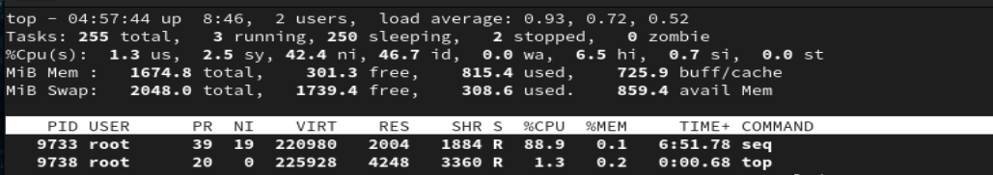
- Change the nice value of the running process.
- Verify the updated nice value.
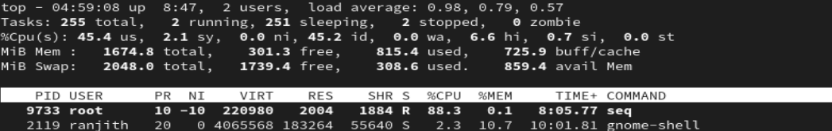
- Observe system behavior after priority change.


---

## PART 4: Process Termination using `kill`

### Scenario
A process becomes unresponsive and must be terminated.

### Tasks

- Identify a running process to terminate.
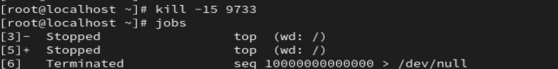

- Terminate the process using a normal signal.
- Verify that the process has stopped.
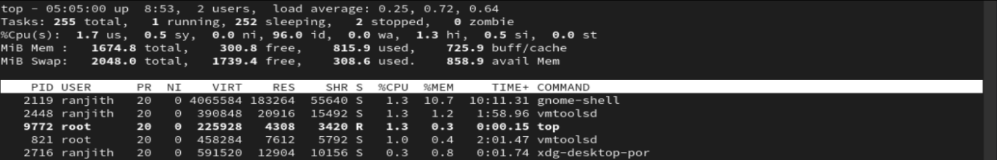
- Start another long-running process.
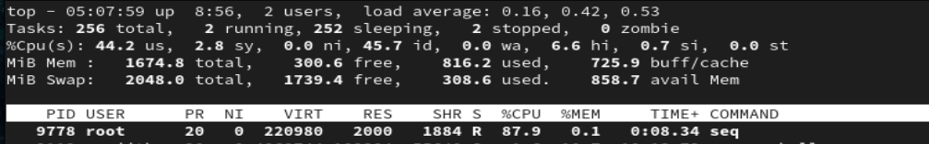
- Terminate the process using a forceful signal.
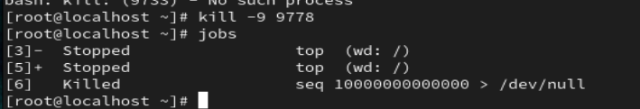
- Verify process termination.
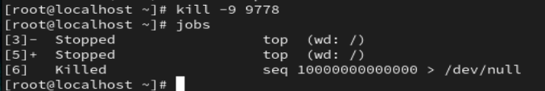

- Observe the difference between normal and forceful termination.

